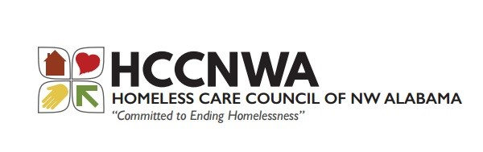
RESULTS OF THE FY2019 COMPETITION APPLICATIONS

Funding in Tier 1 Includes
Community Action Agency of NW Alabama PH & Supportive Services 2019-Renewal $380,739
United Way of NW Alabama HMIS Renewal $13,229
Funding in Tier 2 Includes
United Way of NW Alabama HMIS Renewal $25,146
Not Tiered-per HUD Instructions
HCCNWAL as Collaborative Applicant Planning Grant for CoC $17,872

Total of Funds Requested: $436,986

The ARD amount for our CoC was $419,114, of which 94% was eligible to fund, which equals $393,968.

There was no reallocation or elimination of any grants for this grant cycle.
The rank and review committee met on September 4, 2019 at the Florence Public Library and included the following persons:
Lyndsey Borden, City of Florence Planning and Development
Jackie Milton, NAMI
Michelle Nelson, University of North Alabama
Ashley Smith, Homeless Care Council of NW Alabama

The following was used as ranking and review criteria for these projects:
- Determination and type of project. Priority was given to renewal projects that included Permanent Housing.
- Projects’ ability to serve those determined most vulnerable, including veterans, low income to no income families, and chronic homeless.
- Projects’ capability of entering into HMIS.
- Agencies that were eligible to apply for a CoC HUD Competition.
- Data Quality, Coordinated Assessment participation, and active CoC participants.

